Jasper’s
THE WOODLANDS
PRIVATE DINING

9595 Six Pines Drive
The Woodlands, TX 77380 jaspersthewoodlands.com

Nation’s Restaurant News: Hot Concept! Award Winner Bon Appetit Magazine: Top Ribs in America Esquire Magazine: Top 20 New Restaurants
DiRoNA Award of Excellence
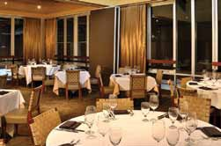
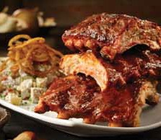
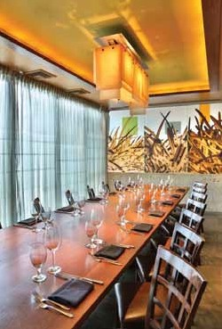

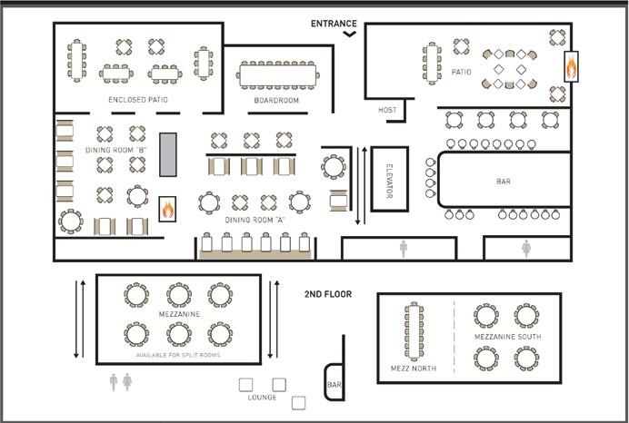
FLOOR PLAN AND CAPACITY
BOARDROOM | 18
PRIVATE DINING/MEZZANINE | 48
MEZZANINE NORTH | 14
MEZZANINE SOUTH | 32
ENCLOSED PATIO | 36
Other table configurations available upon request.
 | jaspersthewoodlands.com

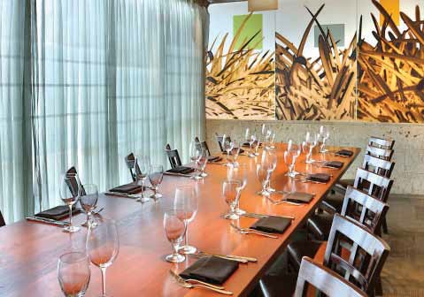
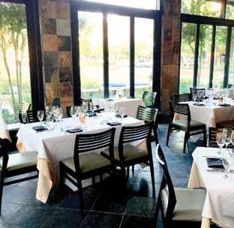
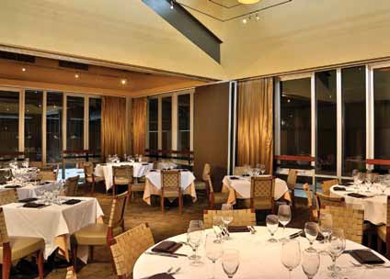
PRIVATE DINING

BOARDROOM

PRIVATE DINING ROOM
ENCLOSED PATIO

jaspersthewoodlands.com

Thank you for thinking of Jasper’s for your special event! I have put together an informative portfolio, which includes our party guidelines and the group menu options. For parties greater than sixteen, Chef recommends a set menu for you and your guests to ensure the best dining experience. Our private dining menus are designed to allow you to create a custom menu for your guests. In addition, a custom heading can be printed at the top of each menu card to be placed at each place setting. After you have decided on a menu, we can pair wines to complement your meal. To further enhance your experience, floral arrangements, bottled water, or any other special needs can be discussed and accommodated.

We have two private dining spaces:
Additional group spaces available, but not private. Ask for details.

The Boardroom Large Private Room Enclosed Patio
*seats 18 people *seats 48 people *seats 36 people
*1 Communal Table *Can also be split to *set menu required
*set menu Optional accommodate 14 or 32 *Completely private
*Completely private *set menu required *audio Visual available
*audio Visual available *Completely private *High speed Wireless Internet
*High speed Wireless Internet *plasma TV in room/audio Visual available
*High speed Wireless Internet

The next step to plan your private event at Jasper’s is to check availability, then confirm the space
with a deposit. Your final menu is due 7 days prior to your event. We thank you for considering Jasper’s for your special occasion, and look forward to working with you very soon.

Thank you,
Amber Campos | Sales Manager 9595 Six Pines Dr., Ste. 900 | The Woodlands, Tx 77380 p. 281.298.5650 | f. 281.298.6621
email: amberc@abacus-jaspers.com

jaspersthewoodlands.com
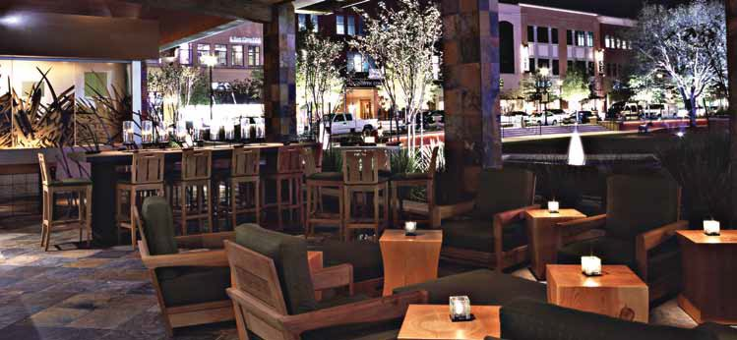

GENERAL INFORMATION / PARTY PLANNING STEPS
There are five steps to planning a successful event at Jasper’s:
- Check availability and secure the space, date and time needed
- return the event Contract to confirm the space
- select a menu for your group (if applicable)
- select wines for your group (if applicable)
- Confirm headcount 72 hours before your event

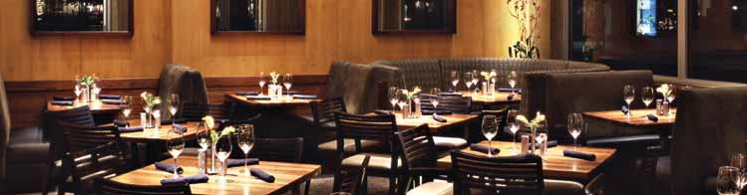

The following information will be useful when planning your special event:

- We are available for lunch events 11:30 am to 3:00 pm Wednesday to Sunday

- We are available for dinner events 5:00 pm to 9:00 pm Wednesday to Thursday, 5:00 pm to 10:00 pm Friday and Saturday.

- Special Arrangements for Audio-Visual equipment, floral displays, and entertainment are available through the restaurant.

- Our private dining room seats up to 48, or up to 75 guests for cocktails and hors d’oeuvres. We also can seat up to 18 in our boardroom. Semi-private dining is also available.

- Custom menu cards will be printed for your dinner. We can customize the heading to greet your guests with a personalized message or company logo.

- Please note that gratuity is not added to your final total. With your permission, the final check can include a predetermined gratuity of your choosing. The event Contract has a section regarding this. Gratuity is customarily between 20% and 23%.

If you have any questions regarding our policies or are ready to plan your special event, please call 281-298-5650 or email me at amberc@abacus-jaspers.com . For more information on our restaurant, you can visit our website at www.jaspersthewoodlands.com . I look forward to helping you plan the perfect event!

Menu pricing subject to change. Please call directly for current pricing.

jaspersthewoodlands.com

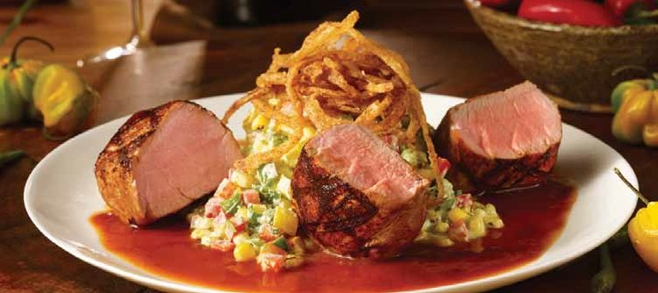
PRIVATE DINING / SPECIAL EVENT MENUS
LUNCH menu 1 $24 – 2 courses menu 2 $24 – 2 courses
menu 3 $30 – 3 courses

DINNER menu 1 $48 – 3 courses menu 2 $58 – 3 courses
menu 3 $68 – 4 courses

Groups under 15 guests may order a la carte
Wine pairings/ suggestions are available upon request

Menu prices do not include tax, gratuity or beverages
Menu pricing subject to change. Please call directly for current pricing

Nation’s Restaurant News: Hot Concept! award Winner Bon Appetit magazine: Top ribs in America Esquire magazine: Top 20 New restaurants
DiroNa award of excellence

jaspersthewoodlands.com

HAND PASSED APPETIZERS (select 3-4 options)
Smoked Chicken Nacho, Cilantro Pesto $2.50/piece
Oven Dried Tomato, Mozzarella, Crisp Pita Chip $2.50/piece
Grilled Thai Chicken or Pork Satay, Sriracha Sour Cream $2.50/piece
Thai Chicken Salad, Crisp Wonton, Lime Dressing $2.50/piece
(Vegetarian also available)
House Smoked Salmon, Lemon Cream Cheese $3.00/piece
Prime Rib Guisado Cones, Avocado Cream $3.00/piece
Texas Gulf Crab Cake, Avocado Cream $3.00/piece
Wood Roasted Shrimp Tostado, Pico de Gallo salsa $3.00/piece Pimentón Seared Filet, Manchego Cheese,
Red Onion-Balsamic marmalade, Crostini $3.00/piece
Black Pepper Seared Lamb Loin, Oven Roasted Tomato Pesto
Pecan Goat Cheese Cracker $3.00/piece
SIGNATURE APPETIZERS FOR THE TABLE
Homemade Bread Board $5/order
Blue Cheese Potato Chips $10/order
Portobello Mushroom and Red Pepper Flatbread $13/order
Feta & Tomato Flatbread $13/order
Crispy Five Spice Calamari, Sweet Chili Vinaigrette $19/order
BITE SIZE TREAT
Lemon Crème Brulée, Candied Lemon $15/Order Fruit Cobbler, Vanilla Bean Ice Cream $15/Order Flourless Chocolate Cake $15/Order

Menu pricing subject to change. Please call directly for current pricing

jaspersthewoodlands.com

LUNCH MENU 1 $24 - 2 COURSE
Menu prices do not include tax, gratuity or beverage
APPETIZER, SOUP Or SALAD (select 2 options)
Masa Soup, Smoked Chicken, Roasted Corn, Black Beans, Jalapeno Cheese
Caesar Salad, Parmesan Reggiano, Croutons
Wedge Salad, Chopped Bacon, Blue Cheese Crumbles, Onion Ring
ENTREE (select 3 options)
Roasted Rotisserie Chicken, Choice of Pesto, Sweet Chile or Herb Seasoning, Roasted Veggies, Corn Grits
Pan Seared Trout, Caper Lemon Butter, Broccolini and Peppers
Wood Grilled Pork Tenderloin, Jalapeño-Charred Corn, Texas Peach BBQ Sauce Slow Smoked Baby Back Ribs, Creamy Baked Potato Salad, Ancho Barbeque Backyard Brisket Cheeseburger, Jasper’s Secret Sauce, Hand Cut Fries
*Vegetarian Option Always Available*

Menu pricing subject to change. Please call directly for current pricing

jaspersthewoodlands.com

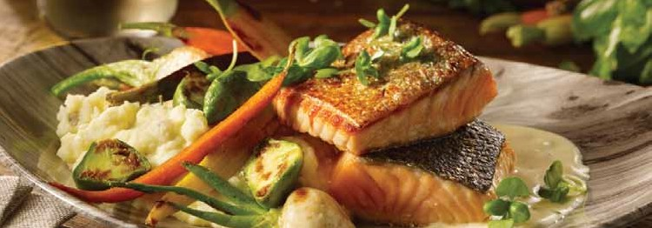

LUNCH MENU 2 $24 - 2 COURSE
Menu prices do not include tax, gratuity or beverage
ENTREE (select 3 options)
Roasted Rotisserie Chicken, Choice of Pesto, Sweet Chile or Herb Seasoning, Roasted Veggies, Corn Grits
Pan Seared Trout, Caper Lemon Butter, Broccolini and Peppers
Wood Grilled Pork Tenderloin, Jalapeño-Charred Corn, Texas Peach BBQ Sauce Slow Smoked Baby Back Ribs, Creamy Baked Potato Salad, Ancho Barbeque Backyard Brisket Cheeseburger, Jasper’s Secret Sauce, Hand Cut Fries
*Vegetarian Option Always Available*
DESSERT (select 2 options)
Lemon Crème Brulée, Candied Lemon
Flourless Chocolate Cake

Menu pricing subject to change. Please call directly for current pricing

jaspersthewoodlands.com

LUNCH MENU 3 $30 - 3 COURSE
Menu prices do not include tax, gratuity or beverage
APPETIZER, SOUP OR SALAD (select 2 options)
Masa Soup, Smoked Chicken, Roasted Corn, Black Beans, Jalapeno Cheese
Caesar Salad, Parmesan Reggiano, Croutons
Wedge Salad, Chopped Bacon, Blue Cheese Crumbles, Onion Ring
ENTREE (select 3 options)
Roasted Rotisserie Chicken, Choice of Pesto, Sweet Chile or Herb Seasoning, Roasted Veggies, Corn Grits
Pan Seared Trout, Caper Lemon Butter, Broccolini and Peppers
Wood Grilled Pork Tenderloin, Jalapeño-Charred Corn, Texas Peach BBQ Sauce Slow Smoked Baby Back Ribs, Creamy Baked Potato Salad, Ancho Barbeque
*Vegetarian Option Always Available*

DESSERT (select 2 options)
Lemon Crème Brulée, Candied Lemon
Flourless Chocolate Cake

Menu pricing subject to change. Please call directly for current pricing

jaspersthewoodlands.com

DINNER MENU 1 $48 - 3 COURSE
Menu prices do not include tax, gratuity or beverage
APPETIZER, SOUP OR SALAD (select 2 options)
Masa Soup, Smoked Chicken, Roasted Corn, Black Beans, Jalapeno Cheese
Caesar Salad, Parmesan Reggiano, Croutons
Wedge Salad, Chopped Bacon, Blue Cheese Crumbles, Onion Ring
ENTREE (select 3 options)
Roasted Rotisserie Chicken, Choice of Pesto, Sweet Chile or Herb Seasoning, Roasted Veggies, Corn Grits
Pan Seared Trout, Caper Lemon Butter, Broccolini and Peppers
Wood Grilled Pork Tenderloin, Jalapeño-Charred Corn, Texas Peach BBQ Sauce Slow Smoked Baby Back Ribs, Creamy Baked Potato Salad, Ancho Barbeque
*Vegetarian Option Always Available*
DESSERT (select 2 options)
Lemon Crème Brulée, Candied Lemon
Flourless Chocolate Cake

Menu pricing subject to change. Please call directly for current pricing

jaspersthewoodlands.com

DINNER MENU 2 $58 - 3 COURSE
Menu prices do not include tax, gratuity or beverage
APPETIZER, SOUP OR SALAD (select 2 options)
Crab Cake, Sambal Lemon Butter, Red Onion, Arugula, Spiced Lemon Oil

Masa Soup, Smoked Chicken, Roasted Corn, Black Beans, Jalapeno Cheese
Caesar Salad, Parmesan Reggiano, Croutons
Wedge Salad, Chopped Bacon, Blue Cheese Crumbles, Onion Ring
ENTREE (select 3 options)
Roasted Rotisserie Chicken, Choice of Pesto, Sweet Chile or Herb Seasoning, Roasted Veggies, Corn Grits
Pan Seared Trout, Caper Lemon Butter, Broccolini and Peppers
Wood Grilled Pork Tenderloin, Jalapeño-Charred Corn, Texas Peach BBQ Sauce Slow Smoked Baby Back Ribs, Creamy Baked Potato Salad, Ancho Barbeque
Black Angus Tenderloin Filet, Garlic Mashed Potatoes, Red Wine Butter
Hearth Smoked Salmon, Roasted Veggies, Lemon Butter
*Vegetarian Option Always Available*
DESSERT (select 2 options)
Lemon Crème Brulée, Candied Lemon
Flourless Chocolate Cake

Menu pricing subject to change. Please call directly for current pricing

jaspersthewoodlands.com

DINNER MENU 3 $68 - 4 COURSE
Menu prices do not include tax, gratuity or beverage
APPETIZER (select 1 option)
Crispy Five Spice Calamari, Sweet Chili Vinaigrette
Crab Cake, Sambal Lemon Butter, Red Onion, Arugula, Spiced Lemon Oil
SOUP OR SALAD (select 2 options)
Masa Soup, Smoked Chicken, Roasted Corn, Black Beans, Jalapeno Cheese
Caesar Salad, Parmesan Reggiano, Croutons
Wedge Salad, Chopped Bacon, Blue Cheese Crumbles, Onion Ring
ENTREE (select 3 options)
Roasted Rotisserie Chicken, Choice of Pesto, Sweet Chile or Herb Seasoning, Roasted Veggies, Corn Grits
Pan Seared Trout, Caper Lemon Butter, Broccolini and Pepper Hearth Smoked Salmon, Roasted Veggies, Lemon Butter
Wood Grilled Pork Tenderloin, Jalapeño-Charred Corn, Texas peach BBQ sauce Slow Smoked Baby Back Ribs, Creamy Baked Potato Salad, Ancho Barbeque
Black Angus Tenderloin Filet, Garlic Mashed Potatoes, Red Wine Butter
*Vegetarian Option Always Available*
DESSERT (select 2 options)
Lemon Crème Brulée, Candied Lemon
Flourless Chocolate Cake

Menu pricing subject to change. Please call directly for current pricing

jaspersthewoodlands.com

